Functional Specifications Document (FSD)

IMS

(Client Portal / Service Management)

Table of Contents

Client Portal 2
Login 2
1. Login 2
Features: 2
Dashboard 4
2) Dashboard 4
Features: 4
3) Repair Management 5
1. Device Section 5
Teltonika Portal 14
1) Service Management 14
1. Device Section 14
2. Stock Section 23
3. CSO Section 30
4. Diagnosis Section 36
5. Repair Section 38
Client Portal Flow Chart
Service Management Flow Chart

Client Portal

Login

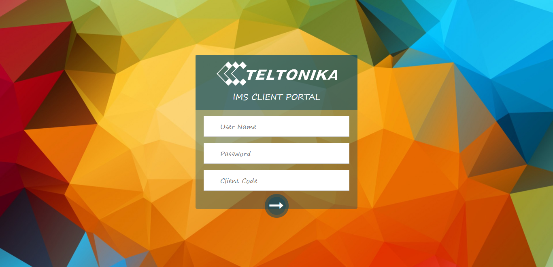

1. Login (Landed to Dashboard)

Features:

1.1. Username, password, client code
- Username textbox to enter valid username.
- Password textbox to enter valid password.
- Client code textbox to enter valid client code.
Purpose: Client code will help us in future when single client need multiple user access to specific module or features.

1.2. Login button
- This button will authenticate user credentials and grant access to application.

1.3. Forgotten account.
Detail: User can reset his/her password in any case. When clicked “Password Reset” modal opens.
Modal Features:
- A textbox where user must enter his/her valid email address.

- “Search” button to validate entered email address.
  - When “Search” button clicked system will authenticate user email and allow him/her to send code.
  - When ‘Send Code” button clicked user will receive a verification code on given email address and allow him/her to enter that verification code on “verification code textbox” which will appear when code successfully sent to given email address.
  - User will enter verification code on given textbox when user clicked “Enter” button if v.code is verified than a “Password textbox” and “Reset Password button” will appear where user can enter desired password and click “Reset Password button”.
  - When “Reset Password button” clicked, on the success of resetting of password, a confirmation mail will send through system to acknowledge user success.

Dashboard

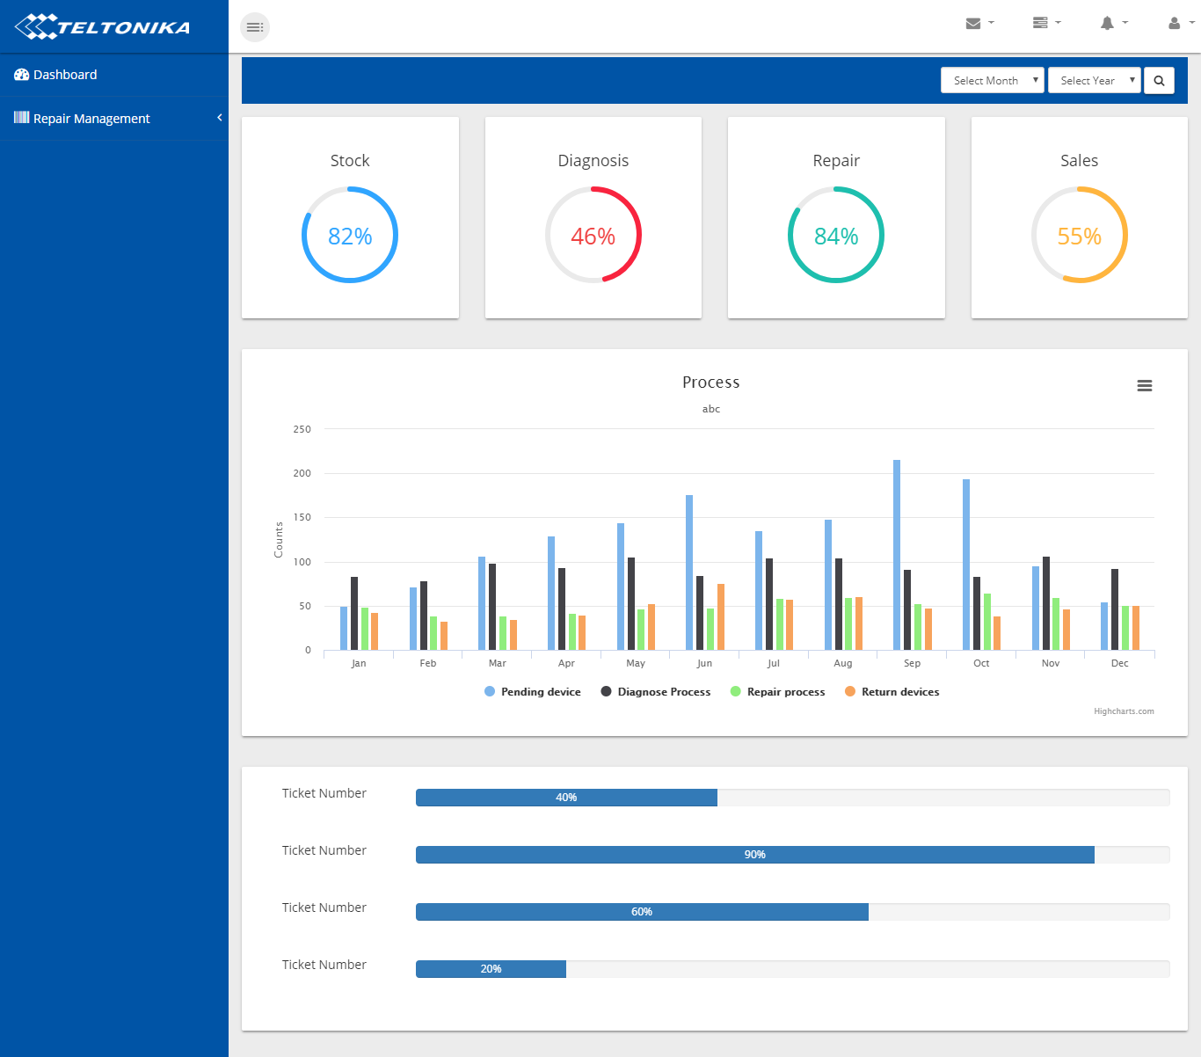

2) Dashboard

Features:
1. Month selection filter
2. Year selection filter
3. Search button
4. Pie-Chart that shows percentage of devices track record w.r.t each section and filter selection.
4. A Bar Graph that shows Pending device, Diagnose Process, Repair process, Return devices (on Y-axis), Ticket# + Date (on X-axis) on behalf of filters selection.
5. Progress bar that shows Ticket# on Y-axis and Percentage of repair completion on X-axis with respect to Ticket# on behalf of filters selection.

3) Repair Management

1. Device Section

  - Add Devices

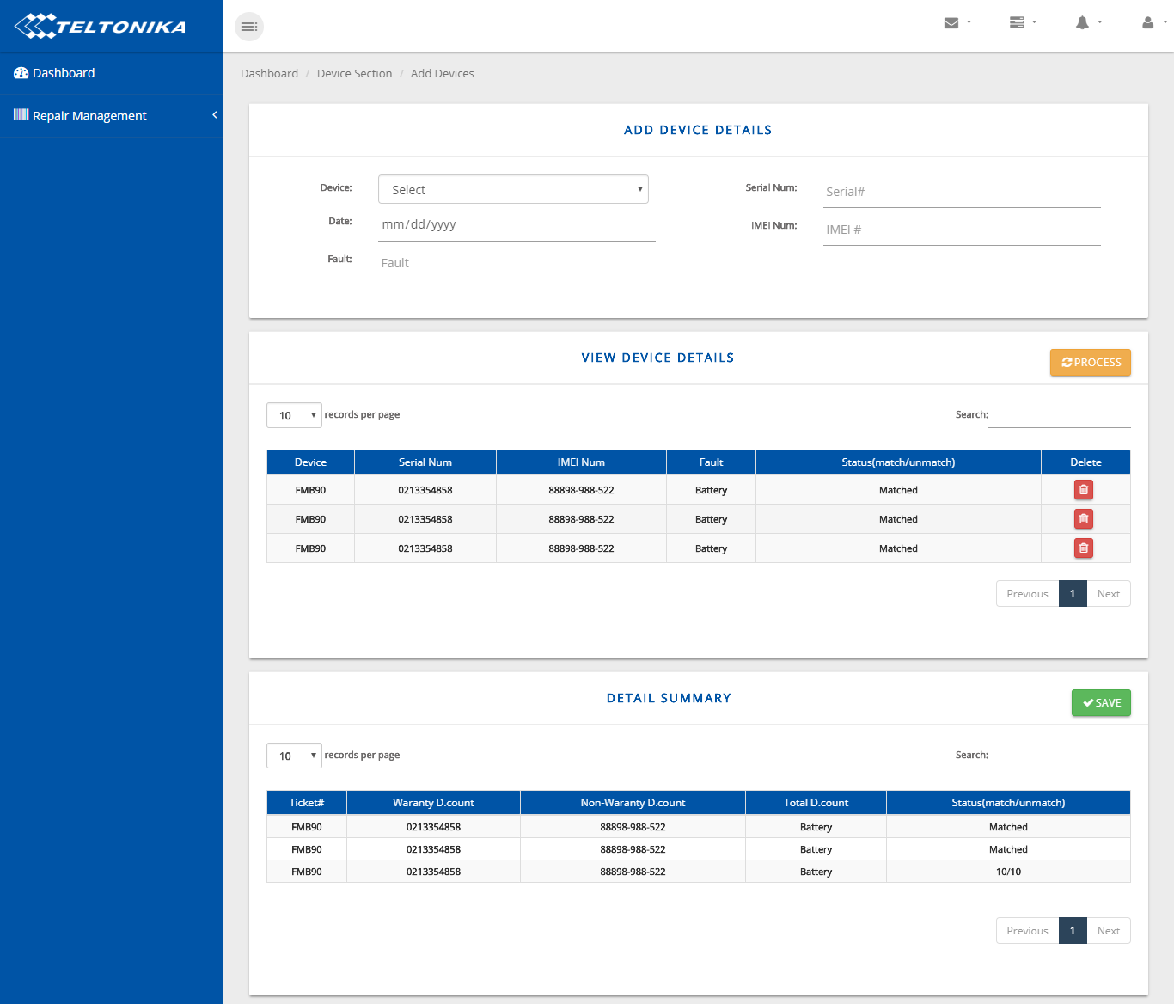
Features:
1.1.1. Device selection
1.1.2. Date selection
1.1.3. Fault entry text field
1.1.4. Serial entry text field
1.1.5. IMEI entry text field for insertion through Bar code scanner.
1.1.6. Add button to enter above record into View device detail table
1.1.7. Process button to get complete initial summary detail of entered devices.
1.1.8. View device detail table that shows all above entered data into it in tabular format with search facility.
Table Columns:
- Device Name
- Serial#
- IMEI
- Fault
- Warranty
- Status (matched/unmatched)
- Delete button
1.1.9. Save button that sends record to device detail section.
1.1.10. Summary table that shows summary in a row.
Table Columns:
- Ticket#
- Warranty D.count
- Non-Warranty D.count
- Total D.count
- Status(matched/unmatched) e.g. 10/10 matched

  - Device Details

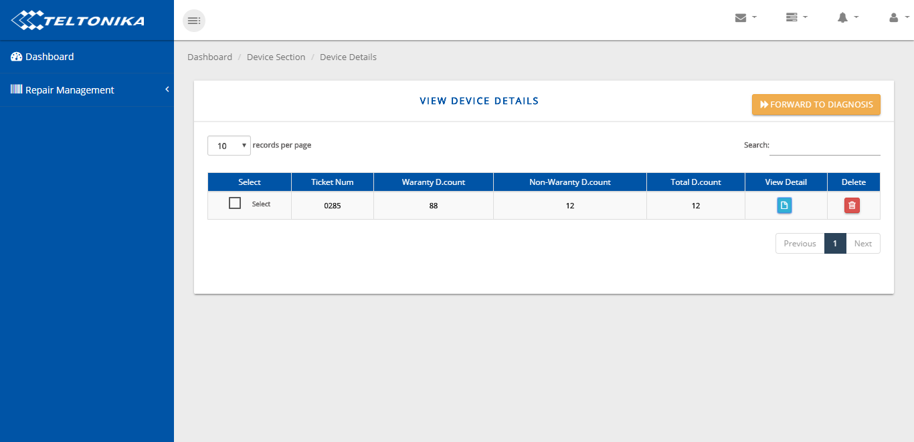

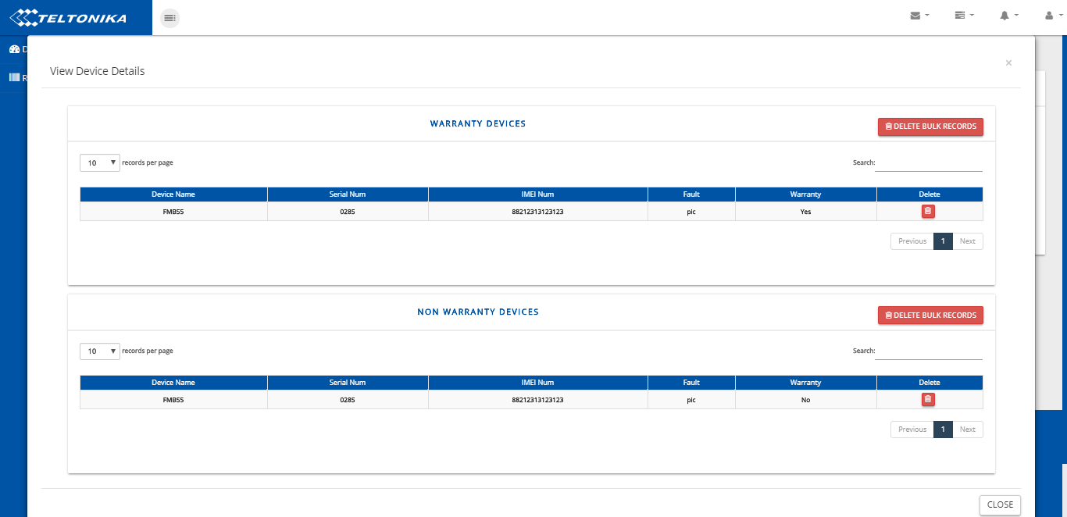

Features:
1.2.1. Device Details Table (with search):
Table Columns:
- Checkbox
- Ticket#
- Warranty D.count
- Non-Warranty D.count
- Total D.count
- show detail button
- delete button

f. show detail button:
Features:
Open modal having two separate tables for warranty device details and other is for non-warranty device details.
- Two Tables (with search):
Tables columns:
- Device Name
- Serial#
- IMEI
- Fault
- Warranty
- delete button

- Two buttons on Top of both tables to delete bulk records.

    - Send for Repair button on top
Features:
Send checked record to Stock section of Teltonika portal app as well as Device History section to maintain history for client review.

  - Device History

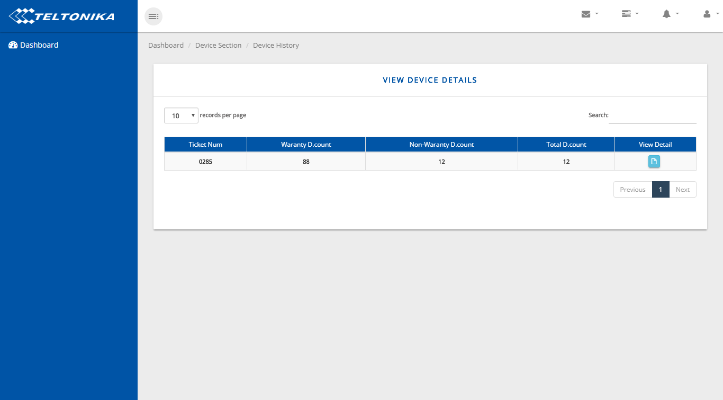

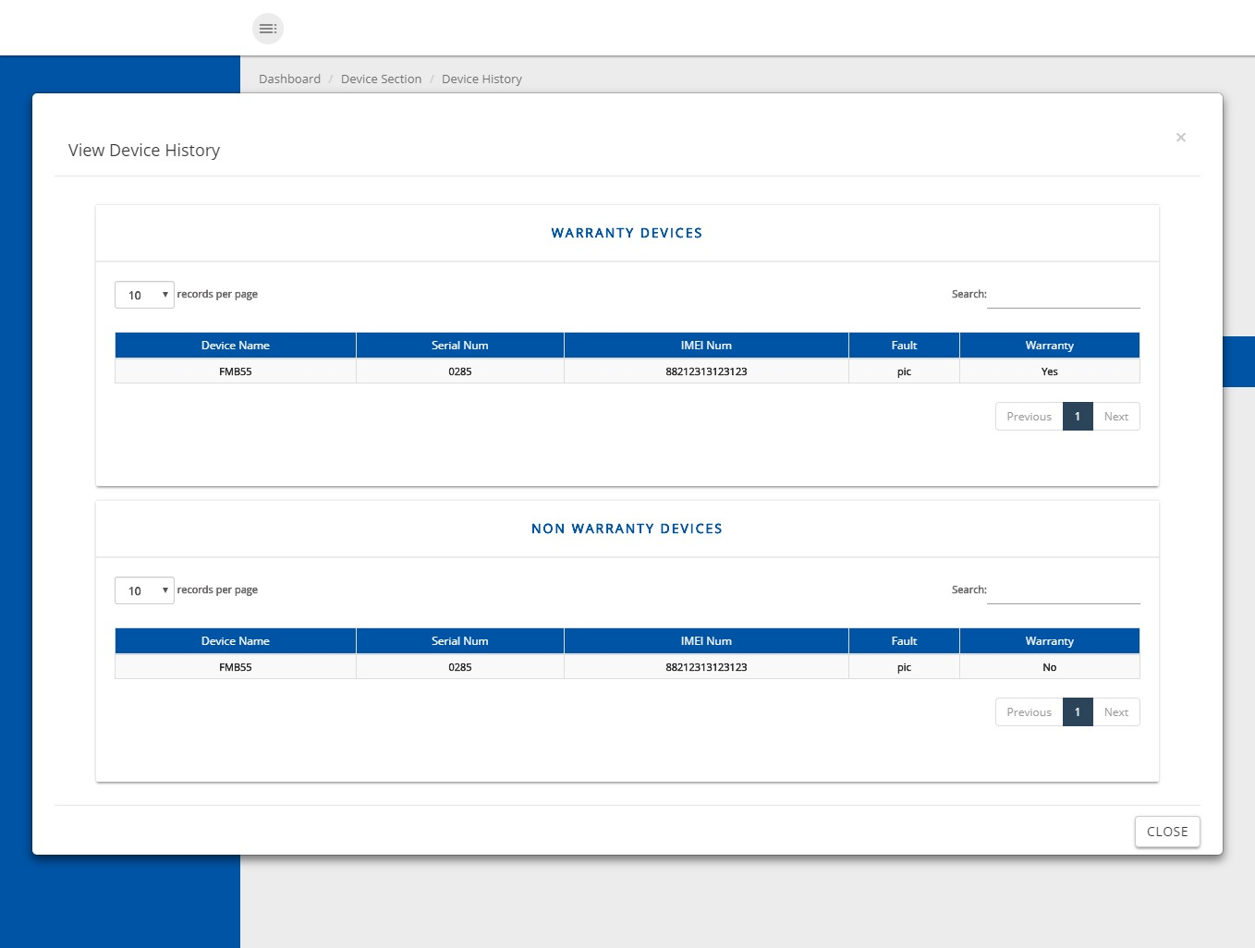

Features:
1.3.1. Table (with search):
Table columns:
- Ticket#
- Warranty D.count
- Non-Warranty D.count
- Total D.count
- Show detail button
e. Show detail button:
Open modal having two separate tables with one warranty device history and other non-warranty device history.
- Tables (with search):
Table Columns:
- Device Name
- Serial#
- IMEI
- Fault
- Warranty

  - Track Devices

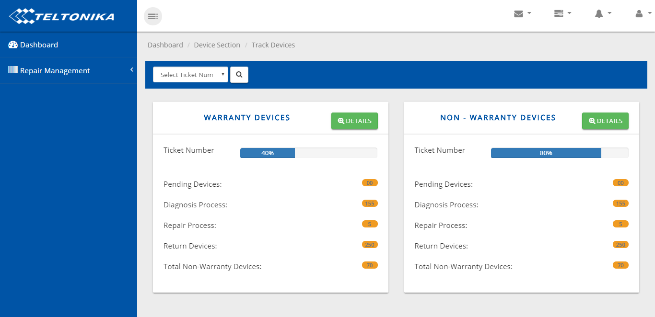

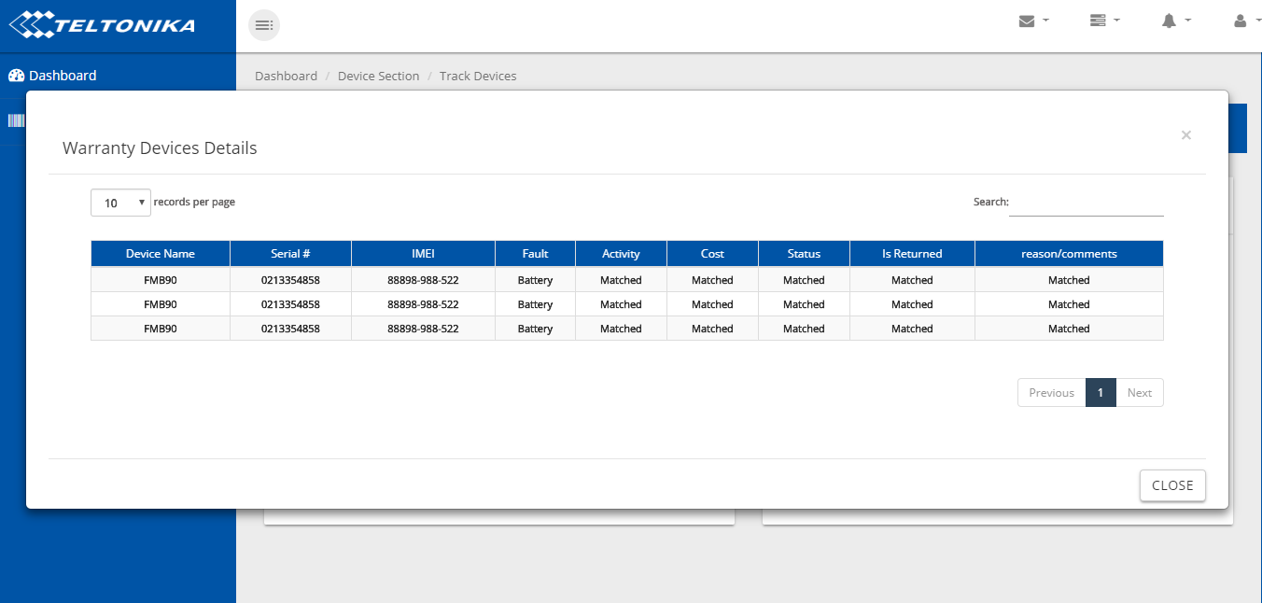

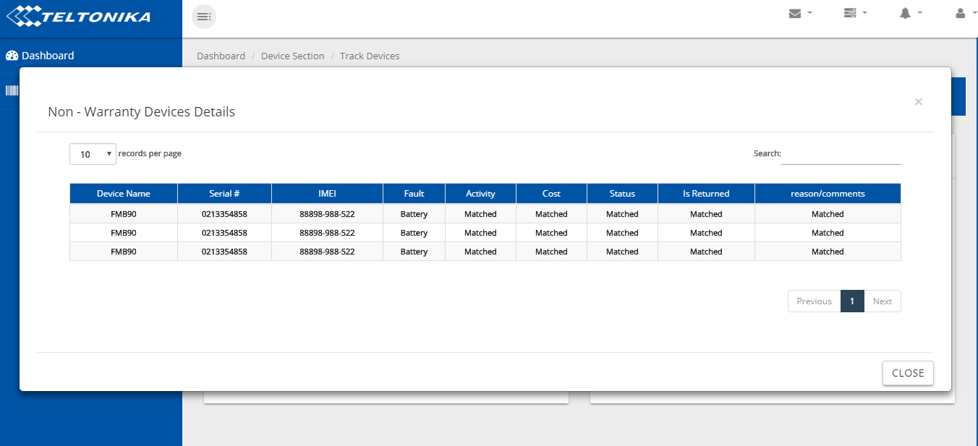

Features:
    - Ticket# selection
    - Search button
    - Two Separate Cards
Features:
Card1 is for warranty devices
Card2 is for non-warranty devices
Card1:
- Details button
- Progress bar
- Pending devices
- Diagnosis Process
- Repair process
- Return devices
- Total Warranty D.count

- Details button:
- Table (Warranty Device details with search):
Table Columns:
- Device Name
- Serial#
- IMEI
- Fault
- Activity
- Cost
- Status
- Return device(Yes/No)
- reason/comments

Card2:
- Details button
- Progress bar
- Pending devices
- Diagnosis Process
- Repair process
- Return devices
- Total Non-Warranty D.count

- Details button:
- Table (Non-Warranty Device details with search):
Table Columns:
- Device Name
- Serial#
- IMEI
- Fault
- Activity
- Cost
- Status
- Return device(Yes/No)
- reason/comments

Teltonika Portal

1) Service Management

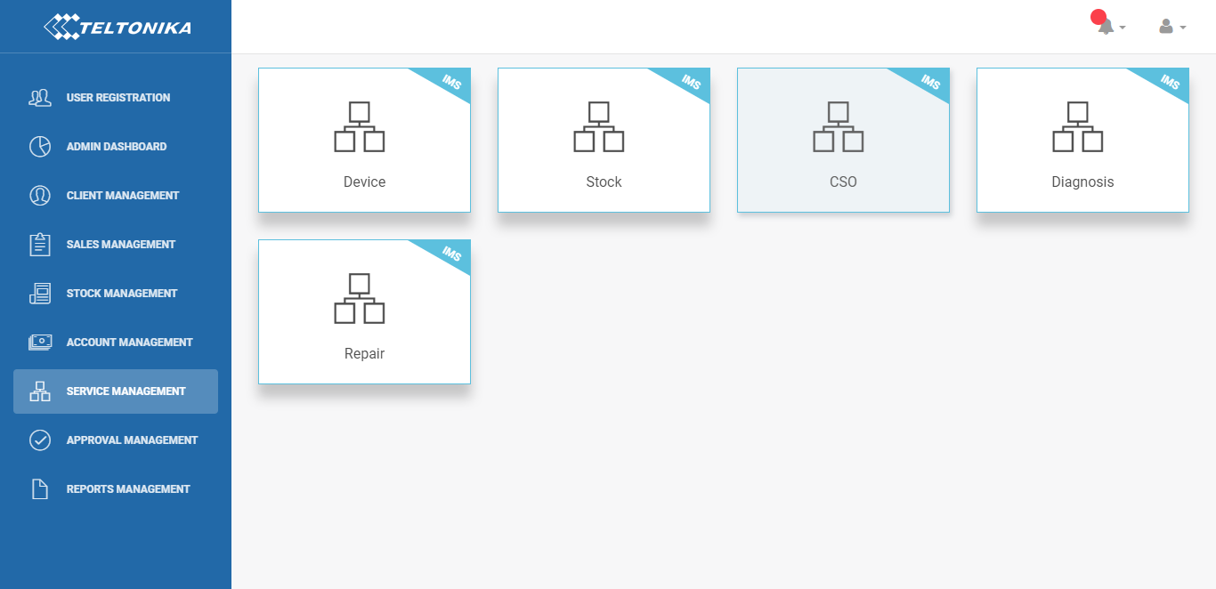

1. Device Section

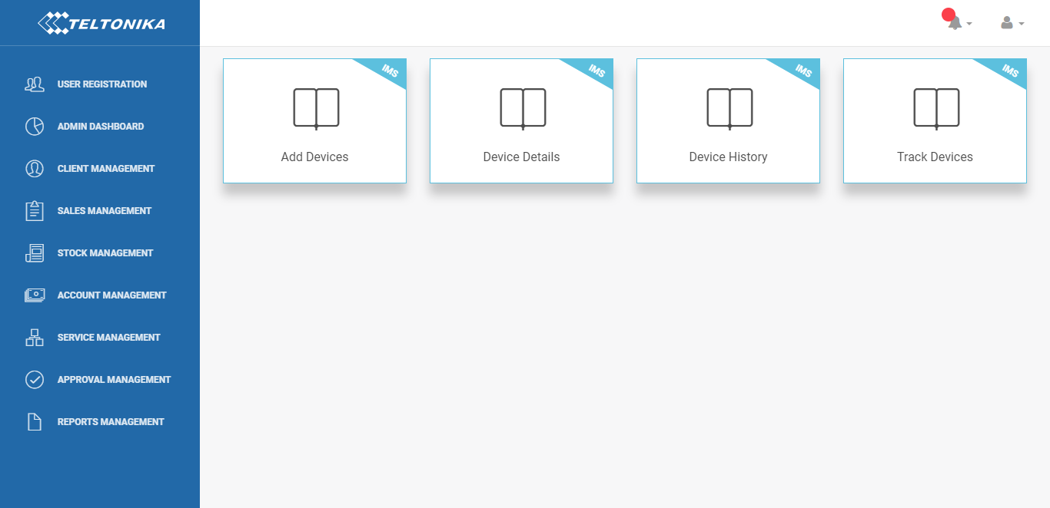

  - Add Devices

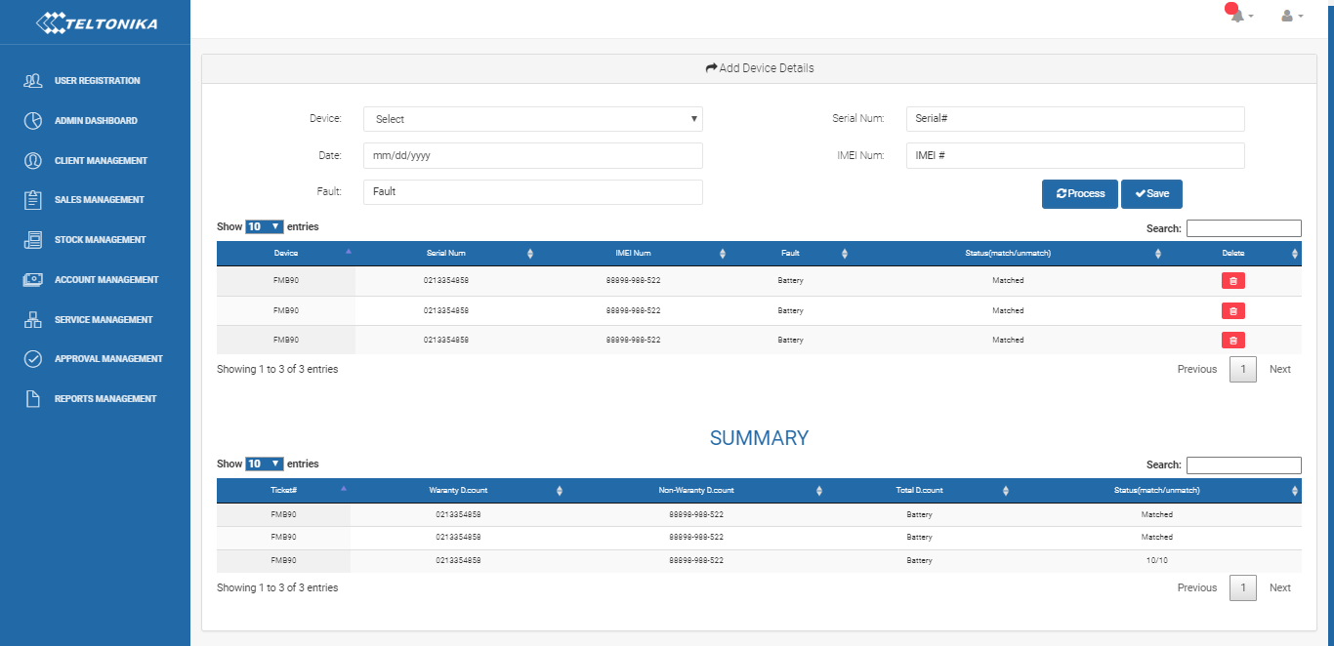
Features:
1.1.1. Device selection
1.1.2. Date selection
1.1.3. Fault entry text field
1.1.4. Serial entry text field
1.1.5. IMEI entry text field for insertion through Bar code scanner.
1.1.6. Add button to enter above record into View device detail table
1.1.7. Process button to get complete initial summary detail of entered devices.
1.1.8. View device detail table that shows all above entered data into it in tabular format with search facility.
Table Columns:
- Device Name
- Serial#
- IMEI
- Fault
- Warranty
- Status (matched/unmatched)
- Delete button
1.1.9. Save button that sends record to device detail section.
1.1.10. Summary table that shows summary in a row.
Table Columns:
  - Ticket#
  - Warranty D.count
  - Non-Warranty D.count
  - Total D.count
  - Status(matched/unmatched) e.g. 10/10 matched

  - Device Details

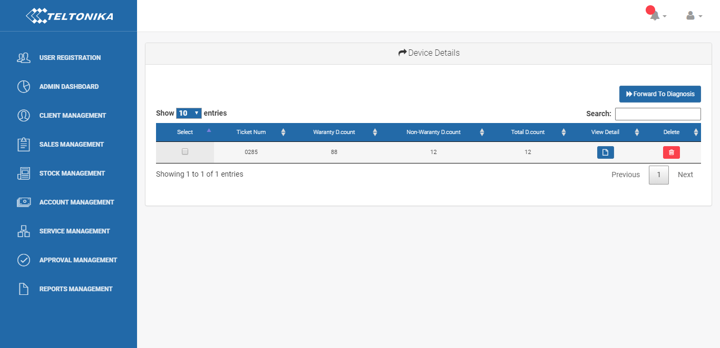

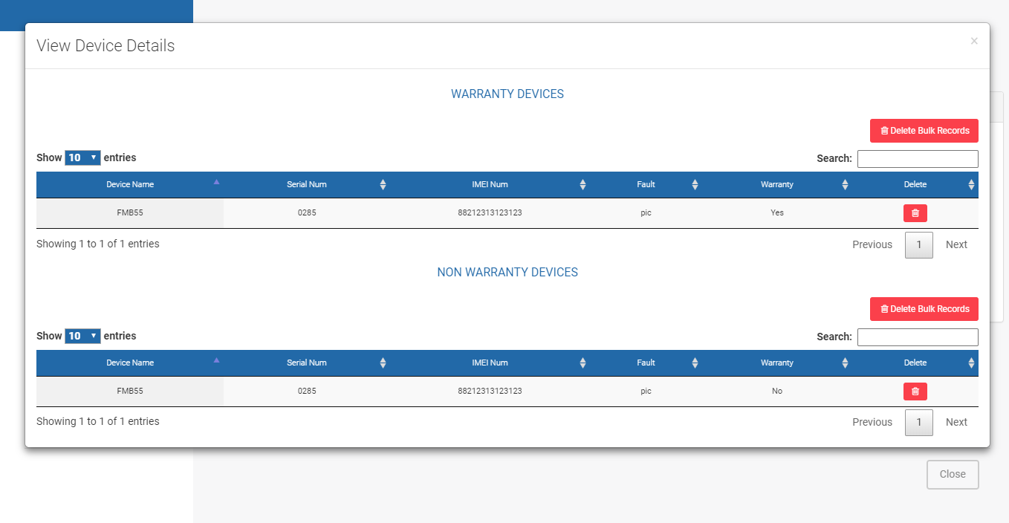

Features:
1.2.1. Device Details Table (with search):
Table Columns:
- Checkbox
- Ticket#
- Warranty D.count
- Non-Warranty D.count
- Total D.count
- Show detail button
- Delete button

f. Show detail button:
Features:
Open modal having two separate tables for warranty device details and other is for non-warranty device details.
- Two Tables (with search):
Tables columns:
- Device Name
- Serial#
- IMEI
- Fault
- Warranty
- delete button

- Two buttons on Top of both tables to delete bulk records.

    - Send for Repair button on top
Features:
Send checked record to Stock section of Teltonika portal app as well as Device History section to maintain history for client review.
  - Device History

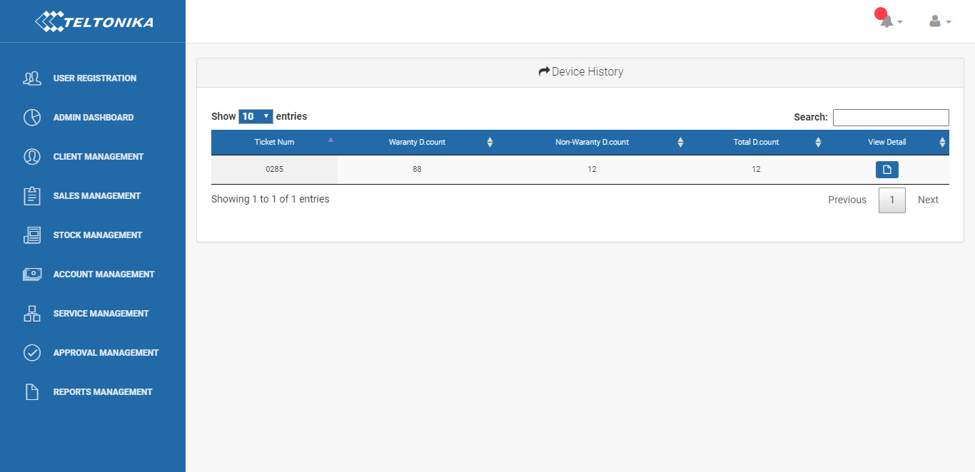

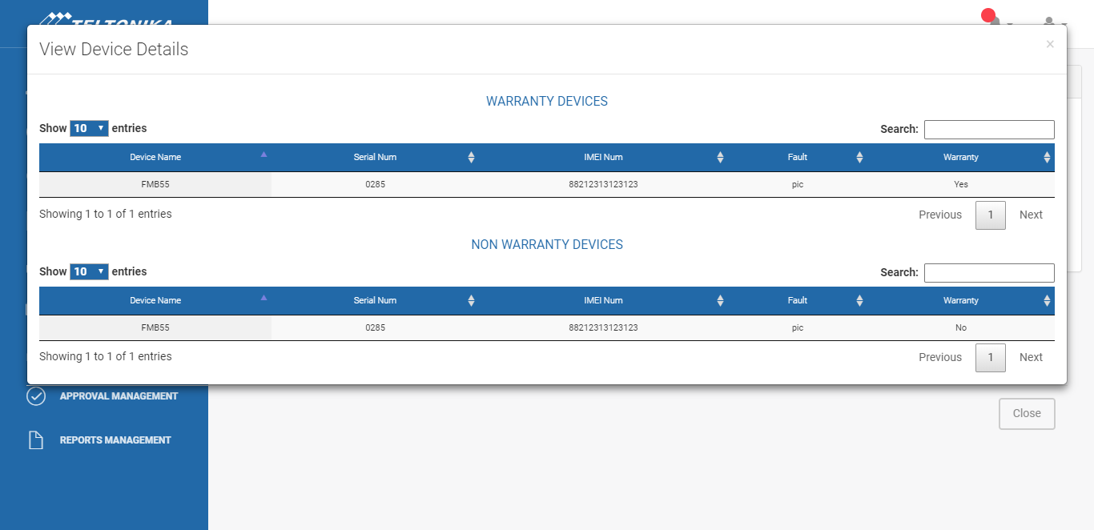

Features:
1.3.1. Table (with search):
Table columns:
- Ticket#
- Warranty D.count
- Non-Warranty D.count
- Total D.count
- Show detail button
e. Show detail button:
Open modal having two separate tables with one warranty device history and other non-warranty device history.
- Tables (with search):
Table Columns:
- Device Name
- Serial#
- IMEI
- Fault
- Warranty

  - Track Devices

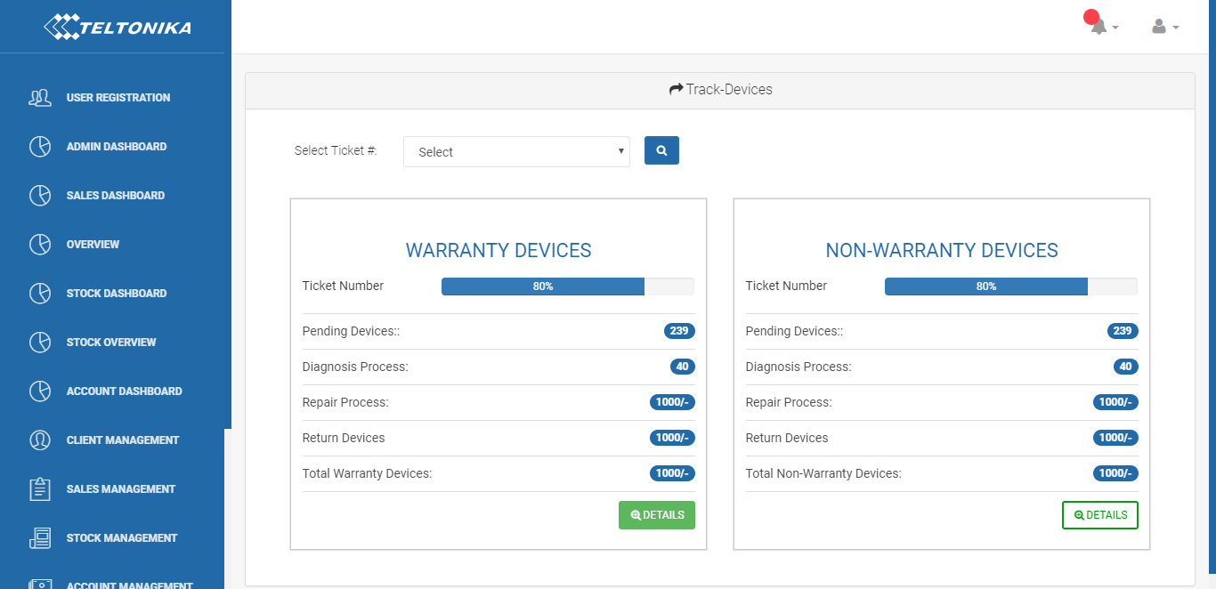

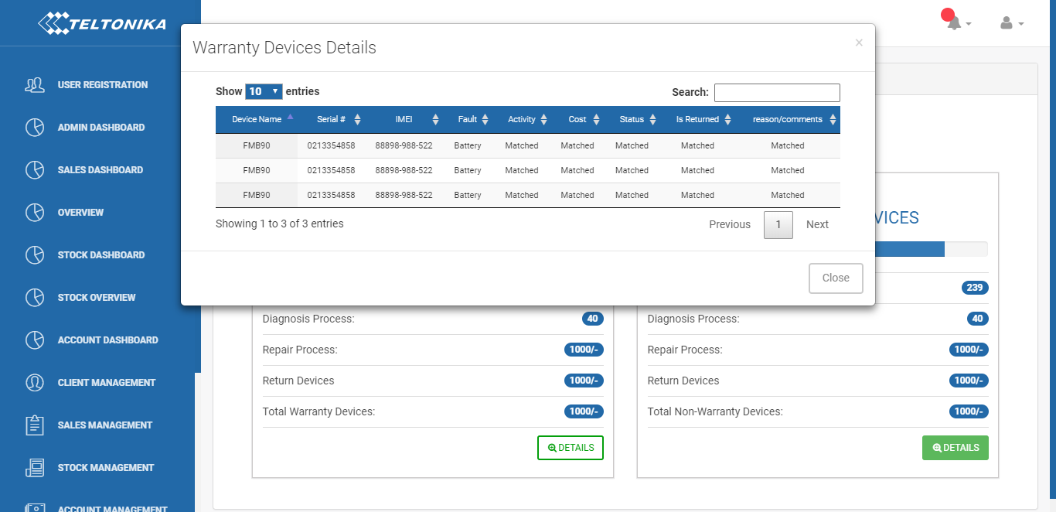

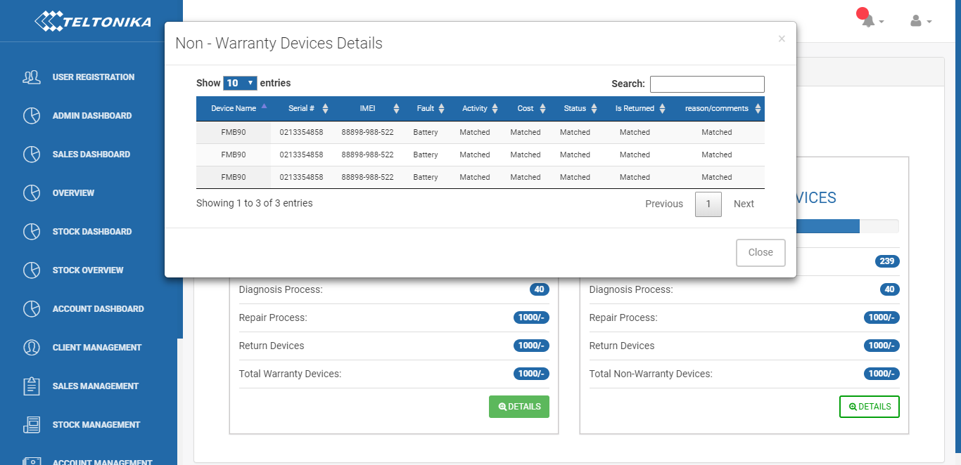

Features:
    - Ticket# selection
    - Search button
    - Two Separate Cards

Features:
Card1 is for warranty devices
Card2 is for non-warranty devices
Card1:
- Details button
- Progress bar
- Pending devices
- Diagnosis Process
- Repair process
- Return devices
- Total Warranty D.count
a. Details button:
- Table (Warranty Device details with search):
Table Columns:
  - Device Name
  - Serial#
  - IMEI
  - Fault
  - Activity
  - Cost
  - Status
  - Return device(Yes/No)
  - reason/comments

Card2:
- Details button
- Progress bar
- Pending devices
- Diagnosis Process
- Repair process
- Return devices
- Total Non-Warranty D.count

- Details button:

- Table (Non-Warranty Device details with search):
Table Columns:
  - Device Name
  - Serial#
  - IMEI
  - Fault
  - Activity
  - Cost
  - Status
  - Return device(Yes/No)
  - reason/comments

2. Stock Section

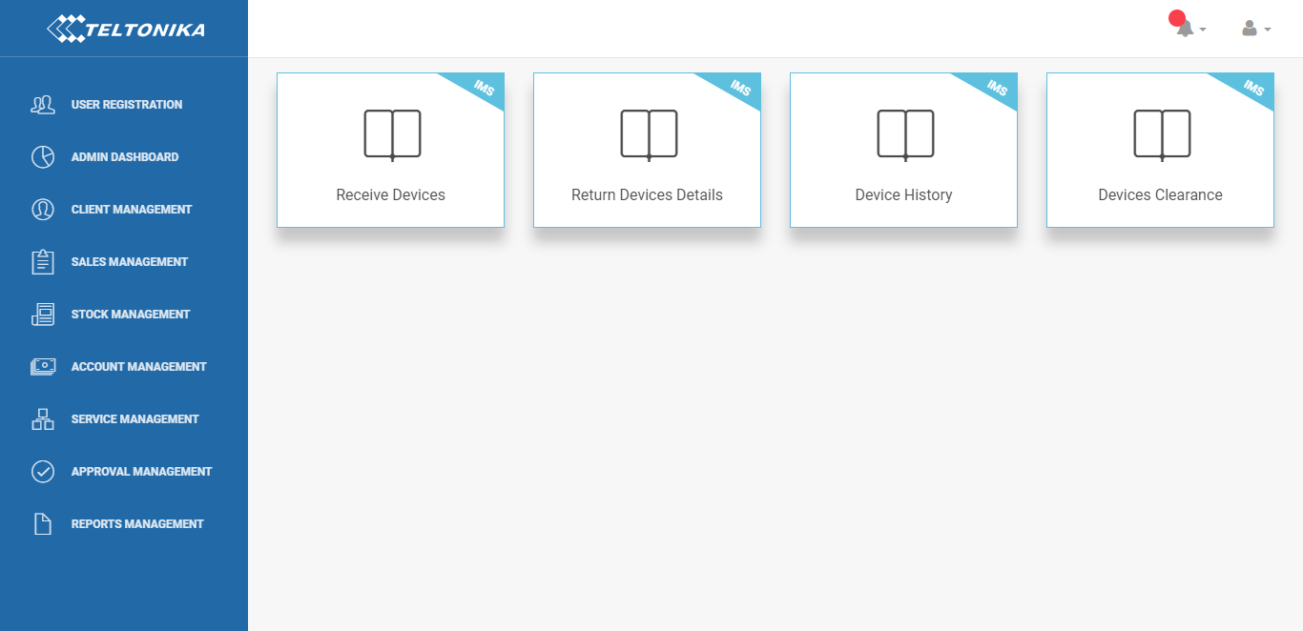

2.1 Receive Devices

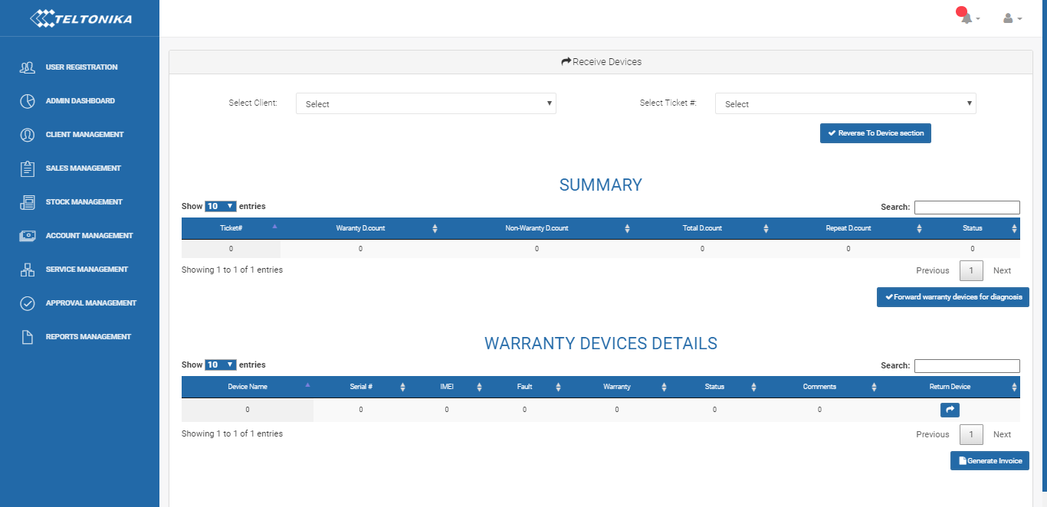

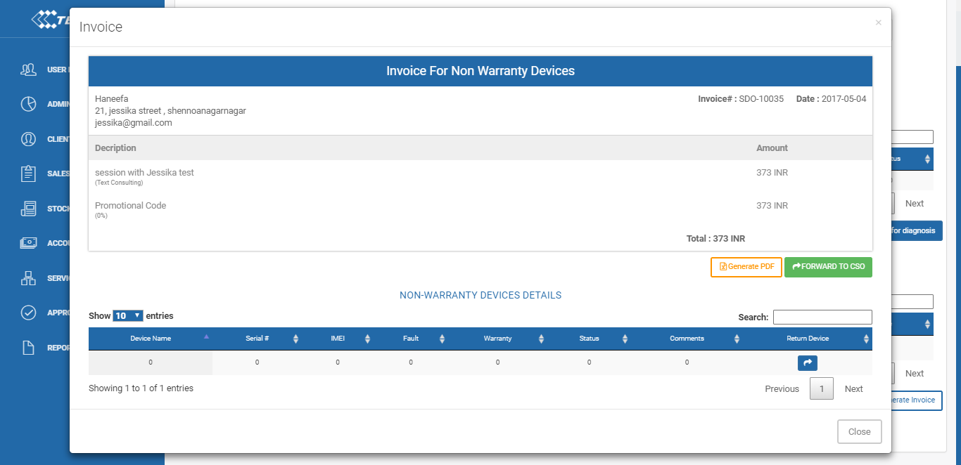

Features:
    - Client selection
    - Ticket# selection
    - Button for Reverse To Device section
Feature:
This button will reverse the entire record of selected Ticket# to previous section which is Device section.
    - Summary Table
Table Columns:
- Ticket#
- Warranty D.count
- Non-Warranty D.count
- Total D.count
- Repeat D.count
- Status

    - Button for Forward warranty devices to Diagnosis section
    - Table (with search)
Table Columns:
- Device Name
- Serial#
- IMEI
- Fault
- Warranty
- Status
- Comments
- Return Device button

    - Button for Invoice generate for diagnosis of only non-warranty devices
Feature:
This button Create invoice and shows it on modal.
Modal Features:
- Invoice Layout
- Generate PDF button
- "Forward To CSO" button for Client approval
Feature: This button Sends invoice and notification to CSO section for Client Approval.
    - Table (with search)
Table Columns:
- Device Name
- Serial#
- IMEI
- Fault
- Warranty
- Status
- Comments
- Return Device button

2.2 Return Devices Detail

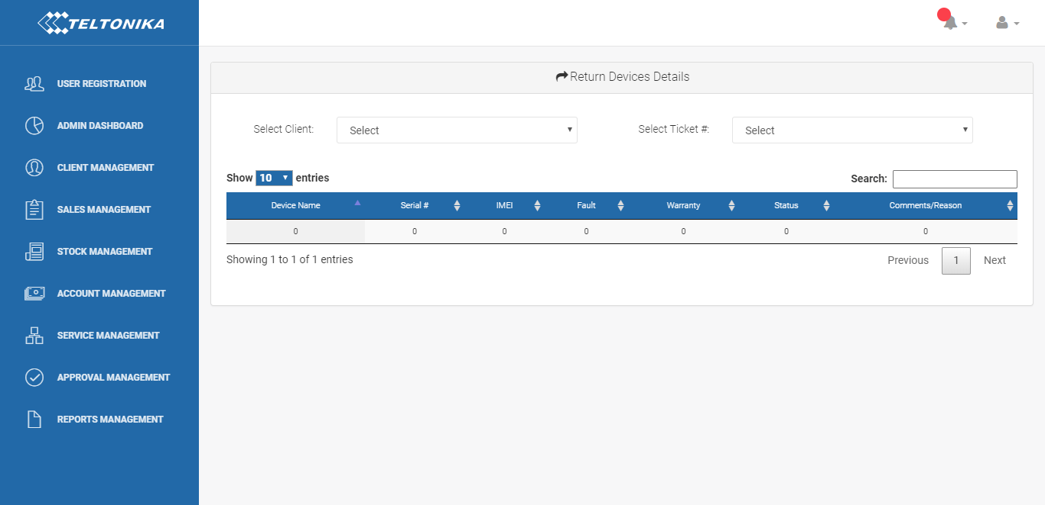

Features:
    - Client selection
(Shows only those clients whose devices return)
    - Ticket# selection
(Shows only those tickets which contains return devices)
    - Table (with search)
Table columns:
- Device Name
- Serial#
- IMEI
- Fault
- Warranty
- Status
- Comments/Reason

2.3 Device History

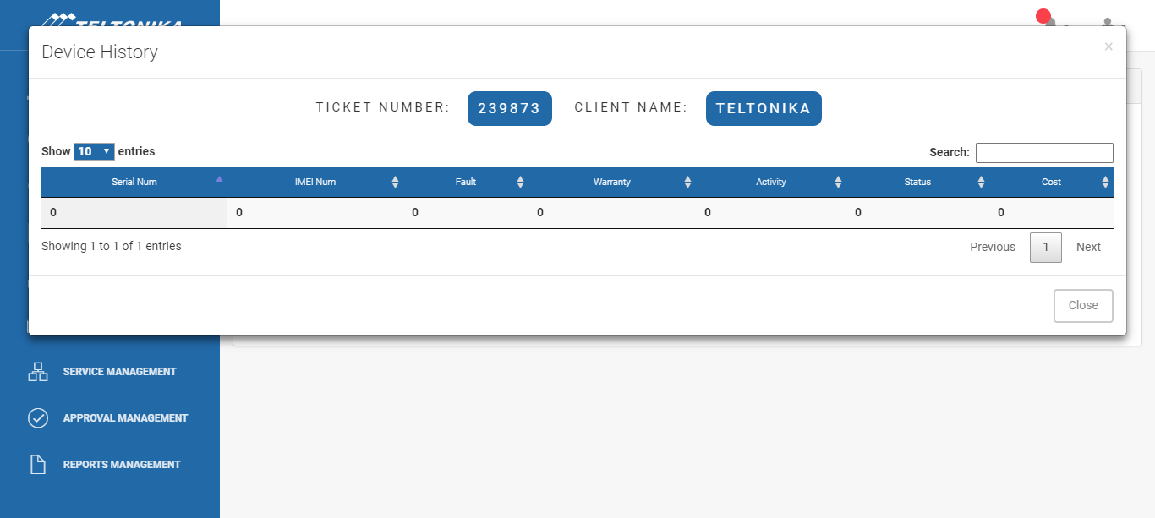

Features:
    - Client selection
    - Ticket# selection
    - Table (with search)
Table columns:
- Ticket#
- Client Name
- Warranty D.count
- Non-Warranty D.count
- Total D.count
- Return D.count
- Status
- show detail button
h. Show detail button:
This button open Modal.
Modal Features:
- Ticket#
- Client name
- Table (with search)
Table columns:
- Serial#
- IMEI
- Warranty
(Yes/no)
- Fault
- Activity
- Status
- Cost
- Lies in which section

  - Devices Clearance

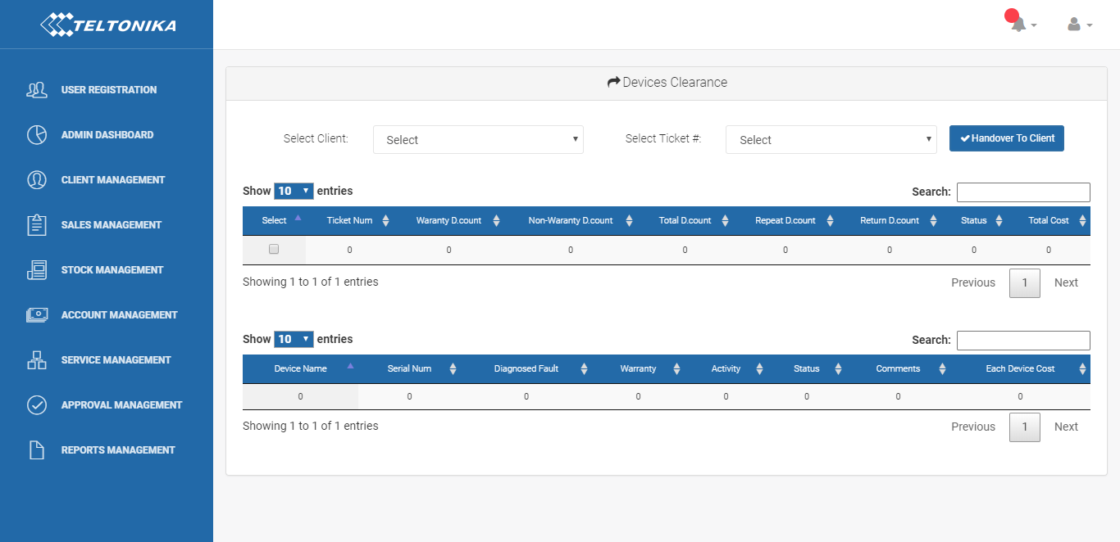

Features:
    - Client selection (shows only those clients whose Payment process is completed or those which send by CSO)
    - Ticket# (shows only those tickets whose Payment process is completed)
    - Handover To Client button
    - Summary table
Table columns:
- Checkbox
- Ticket#
- Warranty D.count
- Non-Warranty D.count
- Total D.count
- Repeat D.count
- Return Device count
- Status
- Total Cost

- Checkbox
Features:
This Update record status when checkbox is checked and "Handover to Client" button is clicked.

    - Table (with search)
Table columns:
- Device Name
- Serial#
- IMEI
- Diagnosed Fault
- Activity Performed
- Warranty
- Status
- Comments
- each device Cost

- CSO Section (All Kinds of Approvals)

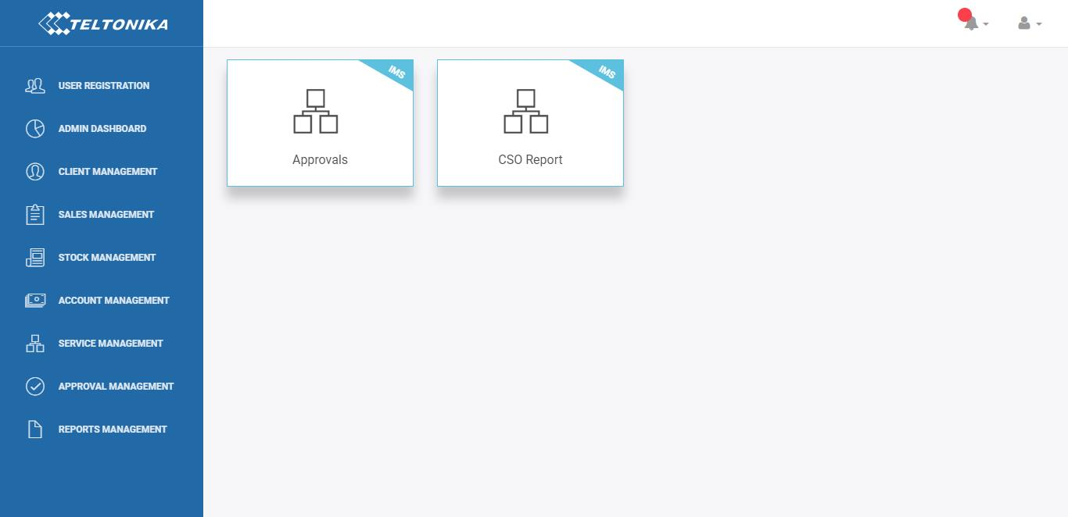

Feature:
3.1. Notifications for Approvals
3.2 Approval

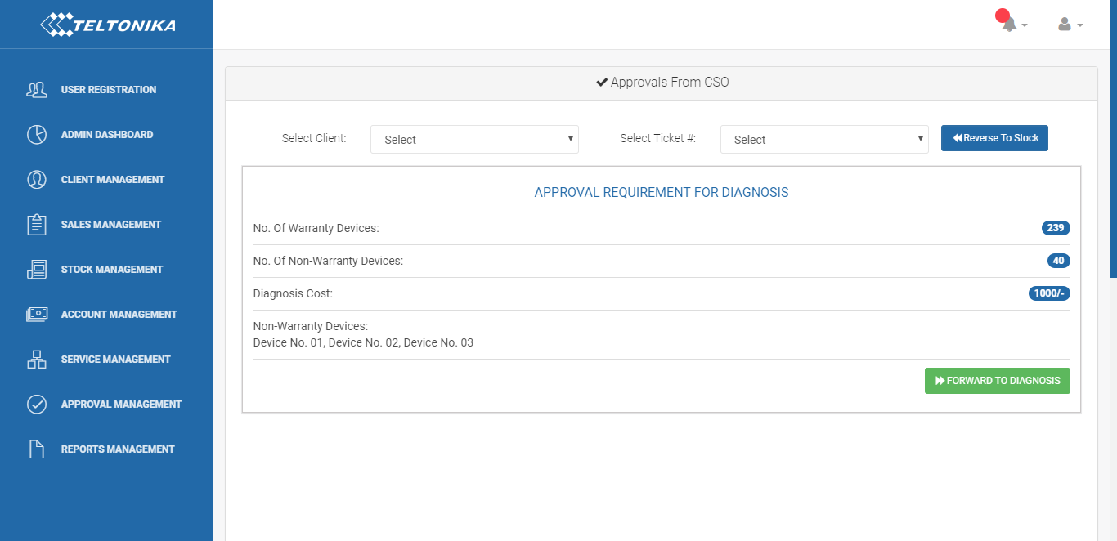

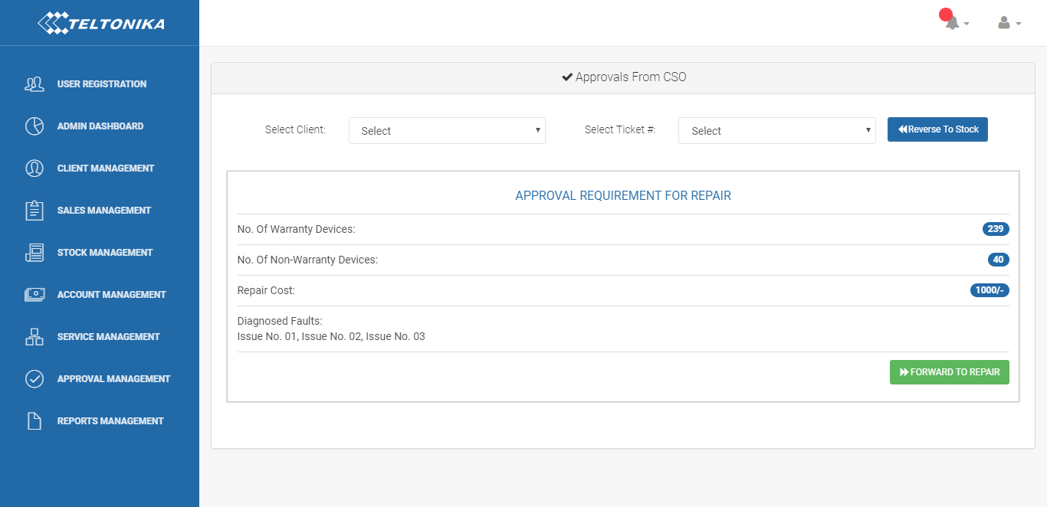
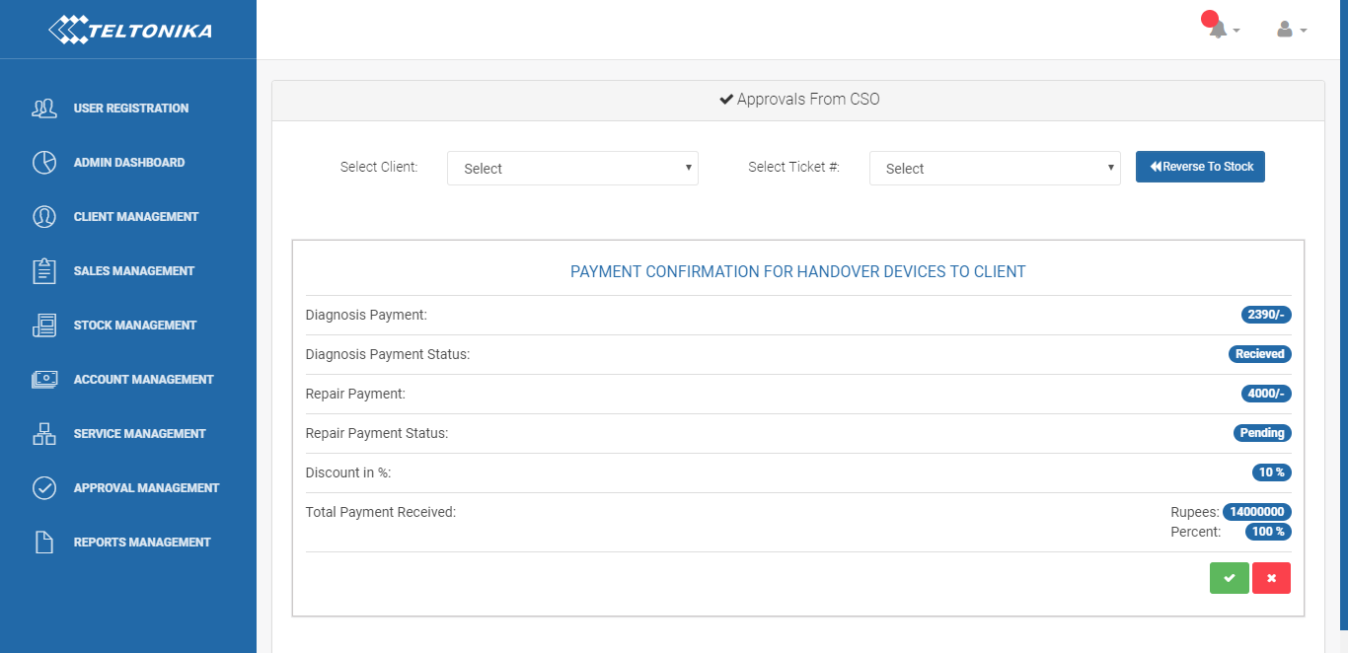

Features:
3.2.1. Client selection (Shows only those clients whose approval is pending)
3.2.2. Ticket# (shows only those tickets which contains approval pending devices)
3.2.3. Button for “Reverse to Stock” section
3.2.4. Card1:
Detail: Shows Approval requirement for Diagnosis.
Features:
    - Warranty D.count
    - Non-warranty D.count
    - Non-warranty Devices' diagnosis cost
    - text box for comment
    - Approve button
3.2.5. Card2:
Detail: Shows Approval requirement for Repair.
Features:
- Warranty D.count
- Non-warranty D.count
- Non-warranty Devices' repair cost
- Diagnosed Faults
- text box for comment
- Total Cost
- Approve button

7. Approve button:
Feature:
Forward to Repair section for further process.

3.2.6. Card3:
Details: Show Payment Confirmation for Handover Devices to Client.

Features:
- Diagnose payment
- Repair payment
- Diagnose payment status.
- Repair payment status.
- Discount in %.
- Total Payment Received in Rs. as well as in %.
- "Handover to Client" button.
- "Handover to Client" button.
- Handover to Client:
This button send Notification and devices to Device Clearance section for Handing over to client.

3.3 CSO Report
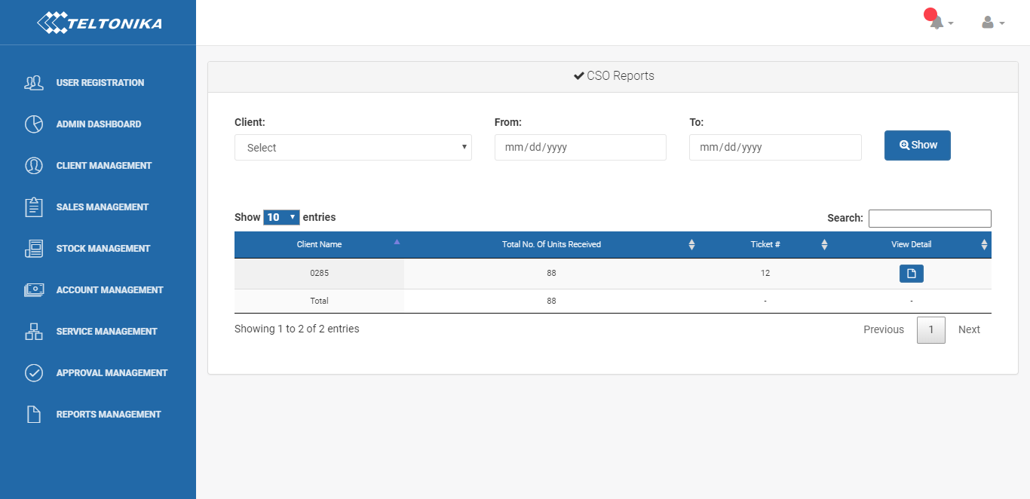

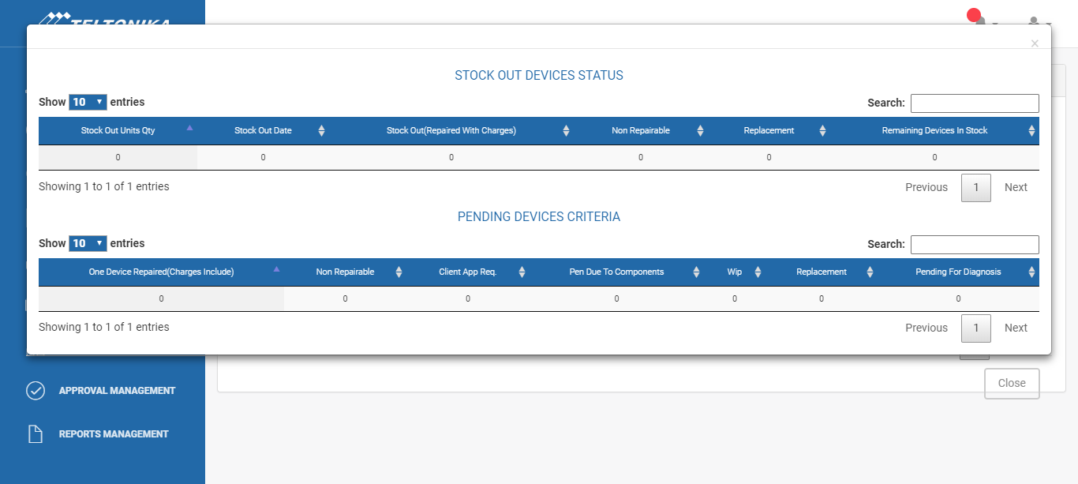

Features:
    - Client selection
    - Date range selection
    - Show button
This button get the requested compiled record in a table.
Table columns:
- Client Name
- Total No. Of Units Received
- Ticket#
- View Detail button
“View Detail” button open a modal.
Modal features:
Modal contains two separate tables

Table 1: Stock Out Device Status
Table columns:
- Stock Out Units Qty
- Stock Out Date
- Stock Out(Repaired with Charges)
- Non-Repairable
- Replacement
- Remaining Devices in Stock

Table 2: Pending Devices Criteria
Table columns:
- One Device Repaired(charges include)
- Non-Repairable
- Client App Req.
- Pen Due To Components
- Wip
- Replacement
- Pending for Diagnose

Diagnosis Section

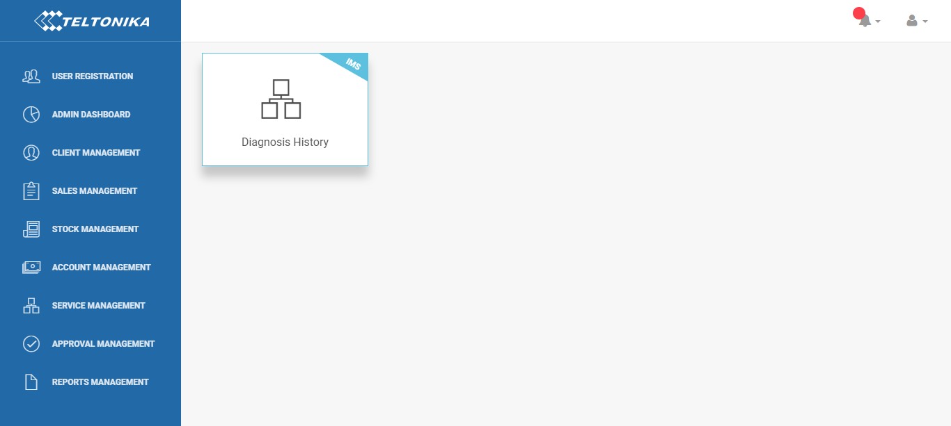

4.1 Device Diagnose History

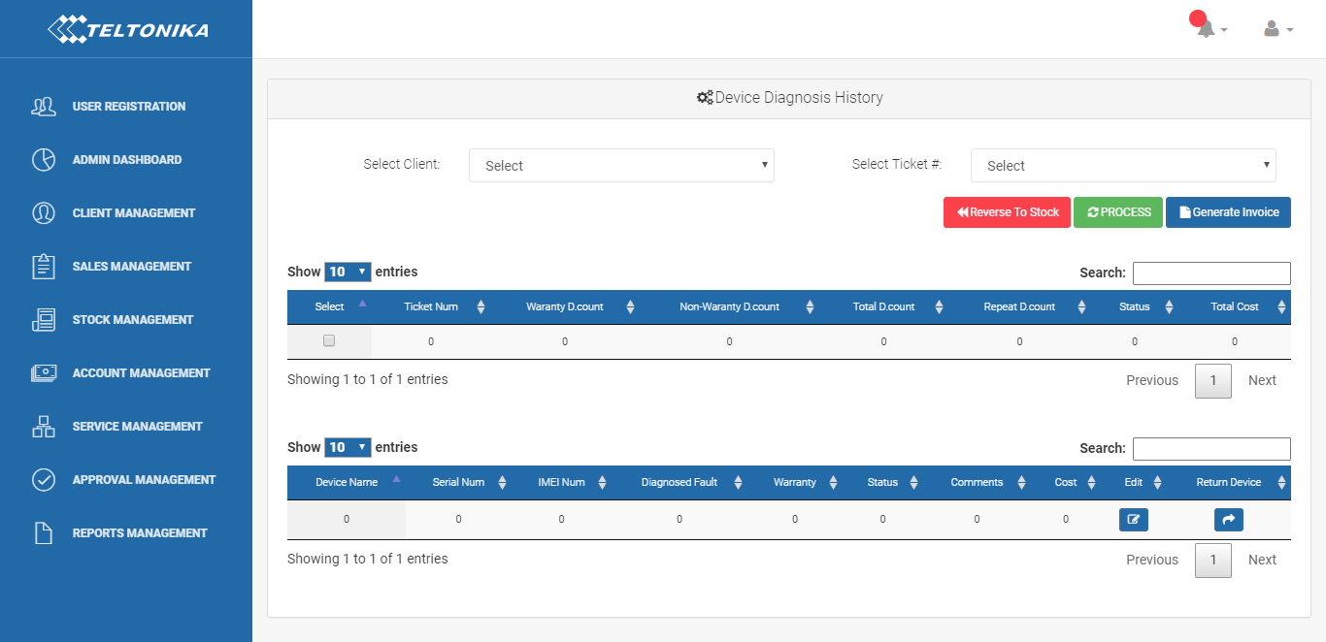

Features:
4.1.1. Client selection
(Shows only those clients whose diagnose approval is done)
4.1.2. Ticket#
(Shows only those tickets which contains diagnose approval done devices)
4.1.3. Button “Reverse to Stock Section”
4.1.4. Process button
Features:
This button will check the following:
  - Diagnosed Fault
  - Status
  - Comments
  - Cost
Columns not to be null and will
  - Update the summary table if any device is return
  - Also Enable "Invoice" button
f. Invoice button:
Feature:
This button generate invoice on a new modal.
Modal contains:
- Invoice Layout
- Generate PDF button
- "Forward To CSO For Repair Approval" button

c. Forward to CSO for Repair Approval:
Feature:
Sends invoice and notification to CSO section for Client Approval.
4.1.5. Summary table
Table columns:
- Ticket#
- Warranty D.count
- Non-Warranty D.count
- Total D.count
- Repeat D.count
- Status
- Total Cost

4.1.6. Table (with search)
Table columns:
- Device Name
- Serial#
- IMEI
- Diagnosed Fault
- Warranty
- Status
- Comments
- Cost
- Edit button
- Return device button

Repair Section

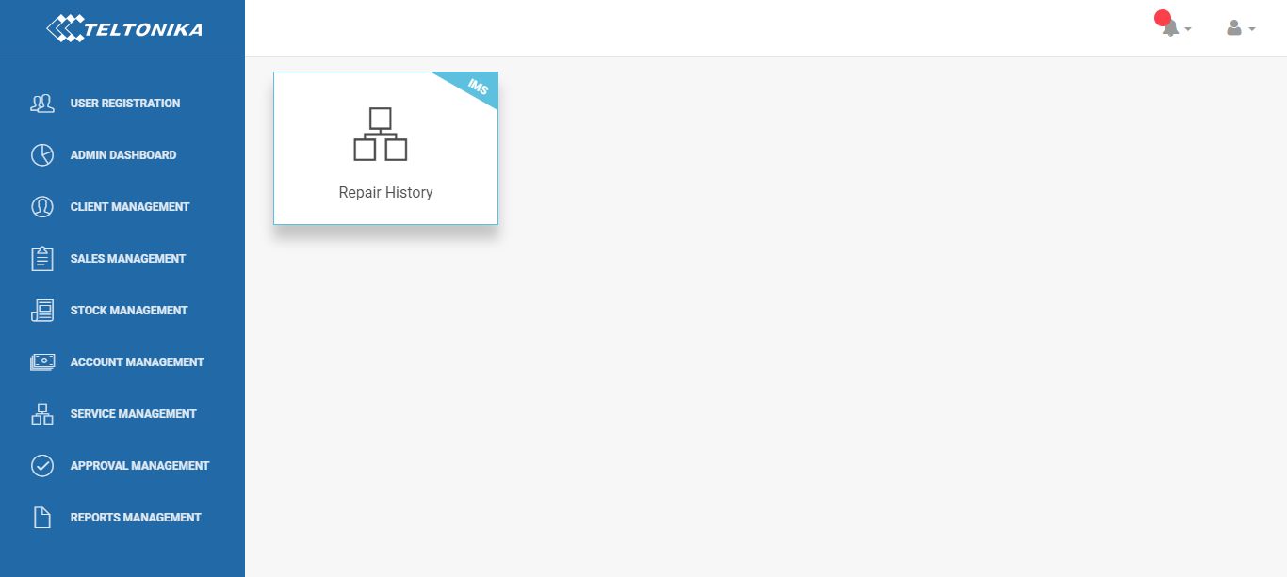

5.1 Device Repair History

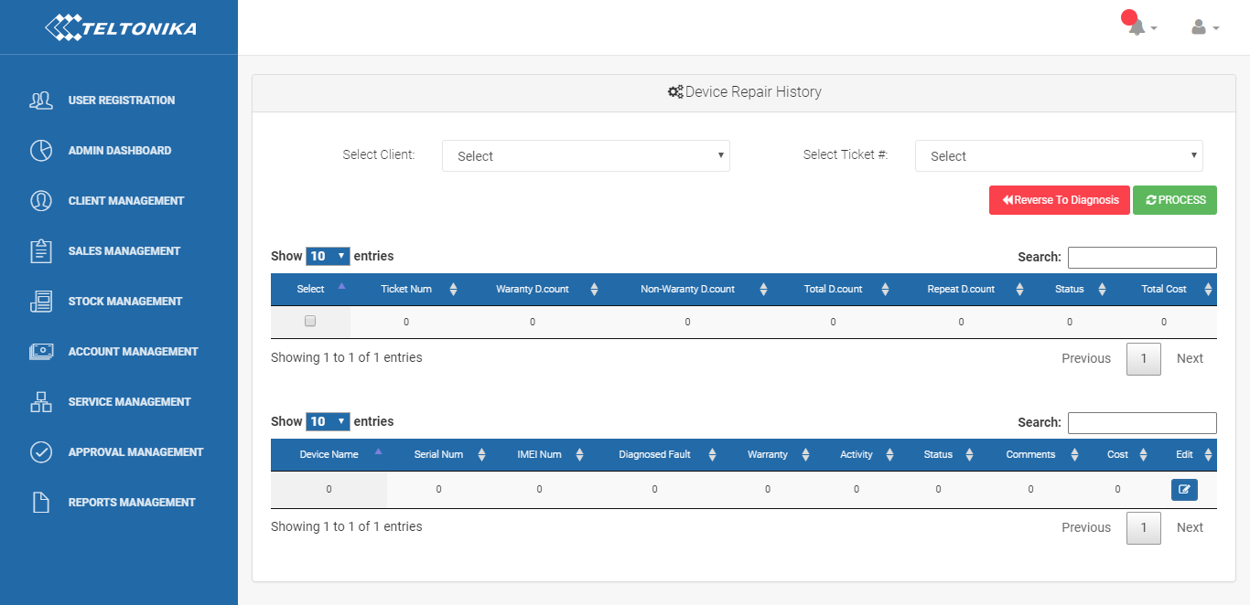

Features:
5.1.1. Client selection
(Shows only those clients whose repair approval is done)
5.1.2. Ticket#
(Shows only those tickets which contains repair approval done devices)
5.1.3. Button “Reverse to Diagnose” section
5.1.4. Process button
Feature:
This button will check the following:
- Diagnosed Fault
- Status
- Comments
- Cost
- Activity
column not to be null and will
- Update the summary table
5.1.5. Summary table
Table columns:
- Ticket#
- Warranty D.count
- Non-Warranty D.count
- Total D.count
- Repeat D.count
- Status
- Total Cost
5.1.6. Table (with search)
Table columns:
- Device Name
- Serial#
- IMEI
- Diagnosed Fault
- Warranty
- Activity
- Status
- Comments
- Cost
- Edit button

5.1.7. Button Send Notification to CSO for repair completion

